**GAP Analysis Document**

Of

**Finance And Accounting Module**

For Implementation of

**Campus Management Software**

at

**World Skill Center (WSC)**



**Sustainable Outreach And Universal**

**Leadership (SOUL) Limited**

Contents

A. Introduction 3

B. Overview of the Document 3

C. List of Screen 4

D. FLOW CHART OF ACCOUTING PROCESS 6

1. SLCM 7

1.1 Program Enrollment 7

1.2 Fees 8

# **Introduction**

The World Skill Center (WSC) is a premier advanced skill training institute established by the Government of Odisha, Skill Development and Technical Education Department, through the Odisha Skill Development Authority (OSDA). The WSC will impart advanced skill training in eight trades from engineering and service sectors. WSC caters primarily to induct the best talent from ITIs and Polytechnics and train them to become globally employable in emerging areas such as "Industry 4.0". WSC is housed in a state-of-the-art, 18-storey, air-conditioned building with nearly half a million square feet of space in the heart of capital city of Bhubaneswar.

With the Implementation of campus management software for WSC the goal is to streamline the operations and functions of the campus by integrating various processes, such as admissions, course registration, academic progress tracking, and financial management, HRMS, Procurement and Inventory management, etc into a unified system. The implementation also aims at providing a user-friendly interface for all stakeholders, making it easier for them to access the necessary information and complete their tasks with ease. The modules to be covered during the implementation of the software includes:

|  |  |
| --- | --- |
| Students Management Modules | Infrastructure Management |
| Academic System | Finance and Accounting System |
| Procurement & Inventory Management | Training and Placement |
| Human Resources Management System | Application Integration |

# **Overview of the Document**

The Gap analysis document is a detailed report that provides an overview of the

gaps between the current state of the project and the desired state, and develop recommendations to close those gaps. Conducting a gap analysis can help us to improve our product and profitability by allowing us to pinpoint “gaps” present in our software. Once it’s complete, we will be able to better focus on our resources and energy on those identified areas in order to improve them.

This document covers all the gaps between the existing software and functional requirements provided by WSC SME’s for Finance and Accounting module.

# **List of Screen**

The table below is list of screens present for the Admission module. Yes in Change in Existing column means that there will be change for a existing screen in the Campus management software, while Is new screen means the screen is not present in the existing software and will be newly developed. This document contains list of changes in existing screens, while requirements for new screens are covered in the SRS document.

|  |  |  |  |
| --- | --- | --- | --- |
| **SL no** | **Name of the Screens** | **Changes in Existing** | **Is New Screen ?** |
|  | Company | No | No |
|  | Chart of Accounts | No | No |
|  | Fiscal Year | No | No |
|  | Accounting Period | No | No |
|  | Finance Book | No | No |
|  | Bank | No | No |
|  | Bank Account | No | No |
|  | Mode of Payment | No | No |
|  | Journal Entry | No | No |
|  | General Ledger | No | No |
|  | Supplier Ledger Summary | No | No |
|  | Payment Entry | No | No |
|  | Accounts Receivable | No | No |
|  | Accounts Receivable Summary | No | No |
|  | Purchase Register | No | No |
|  | Item Wise Purchase Register | No | No |
|  | Supplier | No | No |
|  | Purchase Invoice | No | No |
|  | Accounts Payable | No | No |
|  | Accounts Payable Summary | No | No |
|  | Trial Balance for Party | No | No |
|  | Tax Detail | No | No |
|  | Trial Balance | No | No |
|  | Balance Sheet | No | No |
|  | Profit and Loss Statement | No | No |
|  | Cash Flow | No | No |
|  | Consolidated Financial Statement | No | No |
|  | Bank Reconciliation Tool | No | No |
|  | Bank Clearance | No | No |
|  | Bank Reconciliation Statement | No | No |
|  | Cost Center | No | No |
|  | Accounting Dimension | No | No |
|  | Tax Category | No | No |
|  | Item Tax Template | No | No |
|  | Purchase Taxes and Charges Template | No | No |
|  | Tax Rule | No | No |
|  | Tax Withholding Category | No | No |
|  | Fee Structure | No | No |
|  | Fee Schedule | No | No |
|  | Fees | Yes | No |
|  | Program Enrollment | Yes | No |
|  | Student Re registration Tool | No | No |
|  | Fee Waiver | No | Yes |

# **FLOW CHART OF ACCOUTING PROCESS**

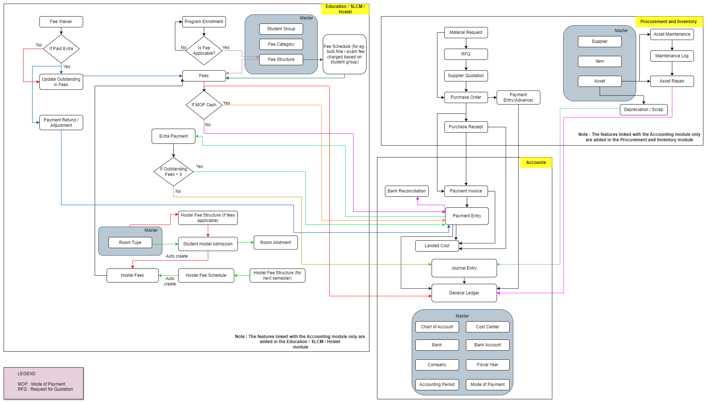

**Note** : The features linked with the Accounting Module are only added in this flowchart

## **SLCM**

### **Program Enrollment**

### 

#### **Description of Changes:**

* During Program Enrollment, for regular students, fee will be charged as per fee structure maintained in Fee Structure screen.
* During Program Enrollment, for those students whose record is maintained at Fee Waiver screen, fees will be charged according to the fee structure maintained in the Fee Waiver screen.

### **Fees**

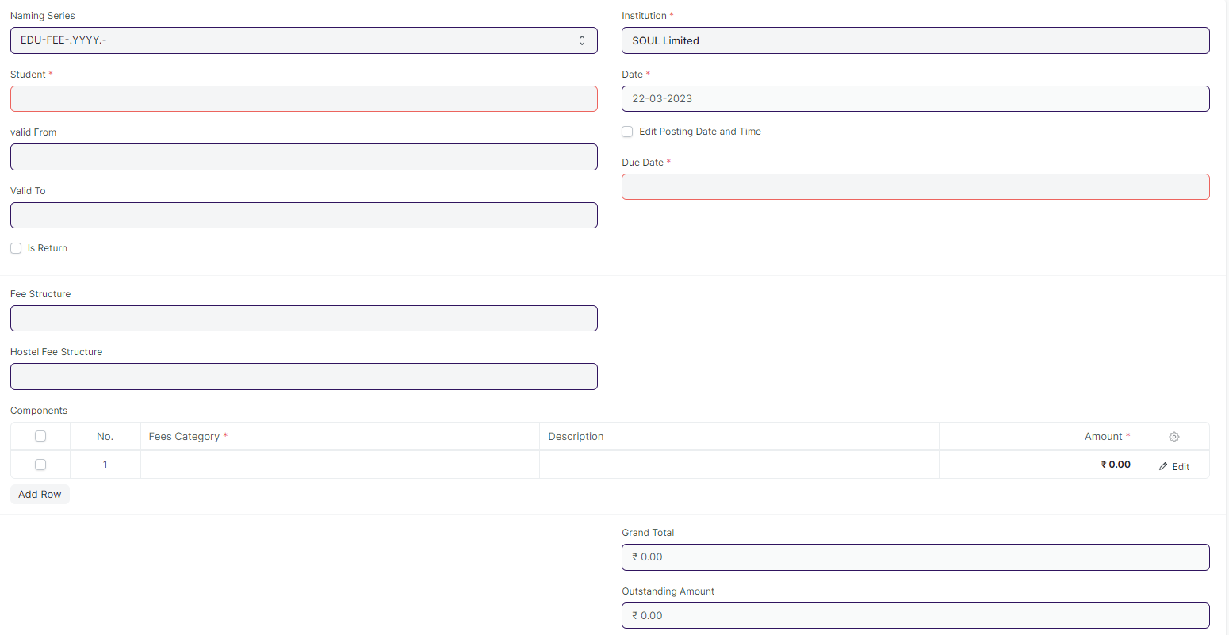

#### **Description of Changes:**

* If any record that is maintained in the Fee Waiver for a particular student for a particular Fee Structure, then the Fee Components will be fetched as per the Fee Components maintained at Fee Waiver screen.